NAME: CHUMA

SURNAME: NXAZONKE

STUDENT NUMBER: 219181187

PROJECT TITLE: THE STATUS OF AI ADOPTION IN SOUTH AFRICAN SUPPLY CHAIN MANAGEMENT: EVOLUTION AND CHALLENGES.

COURSE: PROJECTS (PRJ470S)

SUPERVISOR: AYODEJI AFOLAYAN

CHAPTER 1: INTRODUCTION

Extracting the power of Artificial Intelligence (AI) for supply chain management has become one of the most significant technological revolutions of the 21st century, marking a transformative shift in how goods are produced, distributed, and consumed in global markets. In South Africa, this transition presents both exciting opportunities and formidable challenges, shaped by a complex mix of historical context, socioeconomic disparities, and industrial realities.

The COVID-19 pandemic has advanced digital transformation globally, and South Africa was no exception. Local supply chains came under intense pressure, exposing the urgent need for systems that are more resilient, responsive, and intelligent (Naidoo, 2024). Yet, the road of AI-enabled supply chains in South Africa differs significantly from that of developed economies, characterized by the interplay between innovation potential and systemic constraints.

Globally, AI technologies such as machine learning, predictive analytics, robotic process automation, and Internet of Things (IoT) systems have reshaped supply chain operations. These innovations allow for real-time inventory management, accurate demand forecasting, autonomous logistics, and efficient quality control (Wang & Pan, 2022). Major international players like Amazon, Walmart, and Maersk have demonstrated the impact of AI adoption. Walmart, for instance, reported a 35% drop in inventory levels and a 15% reduction in logistics costs through AI integration (Alick et al., 2021).

South Africa could also benefit greatly from similar technologies, particularly in addressing persistent challenges such as port congestion, transportation inefficiencies, and inventory inaccuracies. These issues are estimated to cost the economy hundreds of billions of rands annually (Naidoo, 2024). However, widespread AI adoption is held back by several local realities. With an unemployment rate of 32.9% in Q4 2023 among the highest globally, the country faces socio-political concerns around job displacement due to automation, especially for low-skilled workers (Stats SA, 2023). At the same time, just 28% of South African universities now provide AI-related courses, indicating a national shortcoming of critical AI and data science expertise (Gwagwa et al., 2022). These human capital constraints are worsened by infrastructure issues such as unstable power and undeveloped digital networks.

In spite of everything, progress is being made. Companies like (Dubai Ports) DP World South Africa and Imperial Logistics have successfully implemented AI technologies to optimize routing and streamline warehouse operations, proving that adoption is not only possible but beneficial (Desai, 2023).

Understanding the full scope of digital transformation in South Africa also requires attention to the country’s historical logistics structure. Although reforms have been made to overcome past inefficiencies, much of the current infrastructure still reflects outdated spatial planning, with economic activity concentrated in a few regions such as Gauteng, Durban, and Cape Town. These imbalances continue to create bottlenecks in the so-called "Golden Triangle" logistics corridor, which handles the bulk of the country's freight (Naidoo, 2024).

As a result of these systemic inefficiencies, South Africa faces logistics costs significantly higher than those in developed economies underscoring the urgent need for AI-driven supply chain optimization in building a more resilient, inclusive, and efficient national logistics framework.

1.2 Background

The evolution of technology in South African supply chains can be viewed in different phases. The 1990s were centric to basic computerization of inventory systems, which then led to ERP adoption in the early 2000’s. In recent times, however, technologies such as IoT sensors, blockchain for traceability, and cloud-based supply chain platforms have been adopted more widely (Pillay & Mafini, 2023). However, AI adoption still in its infancy with just 12% of South African firms report deploying AI in supply chain functions, versus 35% in the UK (Social Security Department, 2023). This gap points to technological and human capital challenges.

The COVID-19 pandemic significantly accelerated timelines for digital transformation. Retails in South Africa was another sector to embrace generative AI Takealot used AI demand forecasting to reduce stockouts during lockdown (Naidoo, 2024), pharmaceutical distributors predictive analytics for COVID-19 vaccines. These agile additions have highlighted the potential of AI, but also the limitations of existing infrastructure for instance, machine learning models could not effectively handle incomplete data from manual record keeping systems, which still account for 60% of South African warehouses (Kruger & Luke, 2024)

This trajectory for AI adoption in South Africa is markedly different from that in developed markets and is determined by the impact of three factors:

- Skill Ecosystems: South Africa does not have the deep bench of AI talent that Silicon Valley or European tech hubs do. This challenge is further compounded by the "brain drain" of skilled professionals to markets such as the UK and Australia, with 45% of local AI graduates leaving within five years (Gwagwa et al., 2022).
- Lack of Infrastructure: Load shedding (planned power outages) impact data center activities, and lack of 5G technology limits real-time IoT application of modern supply chains (Lawlor, 2023).
- Automation: The urgency of 55% youth unemployment has resulted in political inaction towards automatization seen as 'job-killers', even though AI may create new roles for those who annotate training data systems and maintain them after release (et al., 2023)

But through these challenges, leading enterprises are showing the transformative power of AI. AI route optimization decreased empty truck miles by 22% for Imperial Logistics (currently DP World) (Desai, 2023). Woolworths Used It to Optimize Distribution Centres Woolworths had set up computer vision technology to automate quality control in distribution centres, resulting in a reduction of waste by 18%. These approaches are successful, and they also provide examples others can use to scale, but scaling is limited by the constraints mentioned above.

The government is starting to realize the strategic importance of AI due to the release of a draft AI policy framework by the Department of Communications and Digital Technologies recently in 2023 (Technologies, 2023). “But while the private sector pushes ahead, public implementation is lagging behind, underscoring the importance of coordinated public-private partnerships in driving adoption” according to Neil Cole. This context lays the foundation for exploring current adoption trends, impediments, and potential pathways for increased adoption of AI in Supply chain and logistics management in South Africa.

1.3 Problem statement

This integration of artificial intelligence (AI) into supply chains in South Africa, presents a major challenge – while the technology has the potential to resolve long-standing inefficiencies, several structural barriers prevent it from being adopted. South African supply chain industry accounts for 12% of the national GDP while inefficiencies in the supply chain industry cost the country an estimated R480 billion a year. Resolving these challenges successfully could lift GDP by R1. 4 trillion by 2030 according to Accenture while failure can entrench South Africa’s supply chain and economy in financial difficulties.

1.4 Research aim

The aim of this study is to explore the state of AI adoption in the supply chain management in South Africa and the barriers and influencing factors.

1.5 Research questions

1.5.1 Main research question:

- What is the state of AI adoption in the supply chain management sector in South Africa?

1.5.2 Sub-research questions:

- What are the factors affecting the adoption of AI technology in the supply chain management in SA?
- What role does AI adoption play in supply chain management and logistics in South Africa?
- How can the adoption of AI technology be promoted in the supply chain management sector in South Africa?

1.6 Objectives

- To understand and analyze the impact of AI adoption on South African supply chain management.
- To understand the role of AI adoption in supply chain management in South Africa.
- To identify the possible benefits and challenges of adopting AI in South African supply chain management.

Key words: Artificial Intelligence, Supply Chain Management, Adoption, South Africa.

CHAPTER 2: LITERATURE REVIEW

2.1 Introduction

The preceding chapter provided an in-depth introduction to the research, which included a comprehensive overview of the study's background, including the context and past perspective of the issue at hand. Additionally, it introduced the problem statement and presented the study questions that the paper sought to respond to. Moreover, this section elucidated on the study's objectives, including the specific goals and intended outcomes of the research. Finally, it provided a summary of the methodology used in the study, including the research design, data gathering strategies, and data analysis approaches.

AI improved instruments are being used throughout supply chains to improve effectiveness, decrease the influence of a global staff shortage and find improved solutions to move supplies from one spot to another location. Customer care focus vendors are using AI to understand their key population to improve planning about their future behaviour (Sagiroglu & Sinanc, 2013). The previous chapter presented the background, the problem statement, the study objectives and an overview of the study. This section examines the literature on artificial intelligence, supply chain management and logistics. The chapter also provides a scholarly detailed definition of the supply chain. In addition, the chapter presents previous studies on AI adoption and the TOE model. In conclusion, the chapter also presents the application of AI in the supply chain within South Africa (Sagiroglu & Sinanc, 2013).

2.2 Theoretical Framework

The theoretical framework for this research paper is defined in this section. The section also presents
previous TOE-based empirical studies of technological adoption. Tornatzky and Fleisher developed the technology, organisation, and environment (TOE) model, which specifies the elements that influence technology adoption (Zhu et al. 2006). Zhu et al. (2006) developed a framework to help organizations accept and apply technological breakthroughs based on their technical, organizational, and environmental environments.

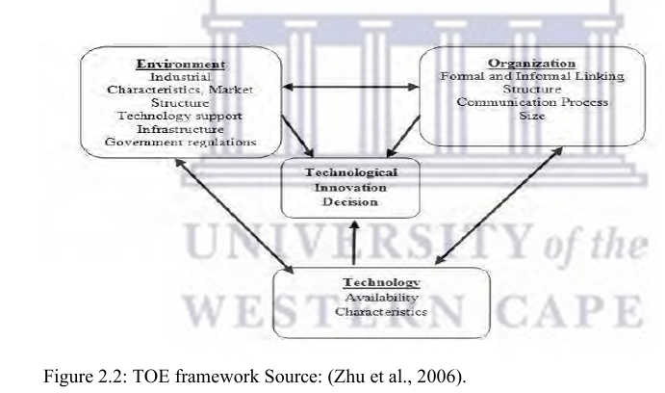

2.2.1 Technology

The technological context encompasses both internal and external technologies already in use at the organization, as well as emerging technologies that may be relevant to it., as well as those which are at the time accessible in the market but are not yet being utilised by the company (Hwang, Huang & Wu,2016). Technology may comprise both equipment and processes. Existing technologies are crucial in the adoption procedure, since they restrict the magnitude and rate of change in technology that a firm may make (Baker, 2012). According to Baker (2012) for new technology adoption to be successful, the organisation must have a solid IT infrastructure and technological abilities among workers.

Technological resources have been acknowledged as a significant influence in the effective adoption of technical improvements, like EDI, ERP and the digital market ( Pan & Jang, 2008). According to Zhu et al. (2006) companies with advanced levels of clientele readiness, purchasers' readiness and competition in e-business operations may grow, although more technologically advanced firms with a larger scale of business are more likely to succeed. Additionally, Zhu et al. (2004) noted that technology willingness is the most significant aspect contributing to adoption.

2.2.2 Organization

The organisational framework describes the company's elements, such as its size, resources and management structure (Hwang, Huang & Wu, 2016). Nguyen and Petersen (2017) allude that there
is an inverse connection between company size and the adoption of ICT. A company's size and scope are crucial factors affecting the adoption (Wang et al., 2003). Due to their flexibility and ability to adjust quickly, small and medium enterprises adopt new ICTs compared to larger companies that are inflexible (Kilangi, 2012). Research conducted onTOE model for examining the aspects influencing the adoption of IoT in China's agricultural supply chain indicated that the biggest obstacle to acceptance of technology was expensive (Lin, Lee & Lin, 2016). Other factors included technological resources (Pan & Jang, 2008).

Recent studies continue to highlight that organisational readiness, including leadership support and digital capability, plays a pivotal role in the successful adoption of advanced technologies such as AI in supply chain management. In the South African context, many organisations, particularly in the logistics and manufacturing sectors, face limitations in internal technical expertise and digital infrastructure, which hampers their ability to adopt AI-driven solutions (Chilunjika et al., 2022). Furthermore, the lack of strategic alignment between top management and IT departments often leads to fragmented technology initiatives that do not translate into long-term value. According to Naude and Sutherland (2023), firms that invest in digital leadership and cross-functional collaboration are more likely to overcome these barriers and foster a culture conducive to AI adoption. This underscores the importance of organisational structure and preparedness as foundational enablers in integrating emerging technologies into the supply chain.

2.2.3 Environment

The environmental factor refers to the context in which a business operates; the environment may
incorporate the business market, buyers, players and the government (Hwang, Huang & Wu, 2016). A review of previous studies indicates that competitive pressures influence the adoption of information technology by SMMEs in third-world countries (Jere & Ngidi, 2020). A study conducted by (Mariemuthu, 2019) found that the adoption of AI in banking firms had a positive correlation with competitive pressure. Similarly, Li's (2008) research indicated that manufacturing firms' adoption of e-procurement was influenced significantly by competitive pressures and exterior reinforcement. Additionally, Teo, Lin and Lai (2009) found that trading partners have a significant effect on the adoption of e-procurement.

In recent years, the external environment surrounding South African supply chains has become increasingly dynamic, with digital transformation accelerating due to both global market demands and disruptions such as the COVID-19 pandemic. As noted by Mkhize and Makena (2022), regulatory uncertainty, customer expectations for faster and more transparent service, and increasing global competition have intensified the pressure on businesses to adopt AI and related technologies. Moreover, environmental sustainability goals are also pushing firms to embrace digital tools that can optimize resource use and reduce waste. These external forces serve as both motivators and constraints, influencing the speed and extent to which businesses integrate AI into their operations. In this context, the interplay between market competition, customer expectations, and policy frameworks forms a critical part of the environmental dimension impacting technology adoption.

2.3.4 Previous studies

Several studies highlighted the importance of TOE in understanding the adoption of advanced technologies in the supply chain (Awa, Ukoha & Emecheta, 2016; Savoury, 2019). The TOE framework shown its resilience in the adoption of modern technologies. A study by Wang, Wang and Yang (2010) suggested a TOE framework for examining RFID implementation in trading businesses that are looking to optimise supply chain prominence and procedural performance. The research paper is guided by TOE based model. The TOE framework exhibited its strength in improved technology adoption through these studies. Various quantitative studies have employed the TOE model to investigate the adoption of progressive technology at the business level (Awa, Ukoha & Emecheta, 2016; Savoury, 2019). The studies suggest that the adoption of innovations by firms can be studied utilising the TOE framework.

2.3 Key Technologies Currently Shaping Modern Supply Chain Management

Supply Chain Management (SCM) plays a critical role in ensuring the smooth flow of goods, services, and information from the point of origin to the final customer. The integration of advanced technologies has significantly transformed traditional supply chain practices, enhancing efficiency, visibility, and responsiveness. This research paper provides a comprehensive overview of key technologies that are currently shaping modern supply chain management.

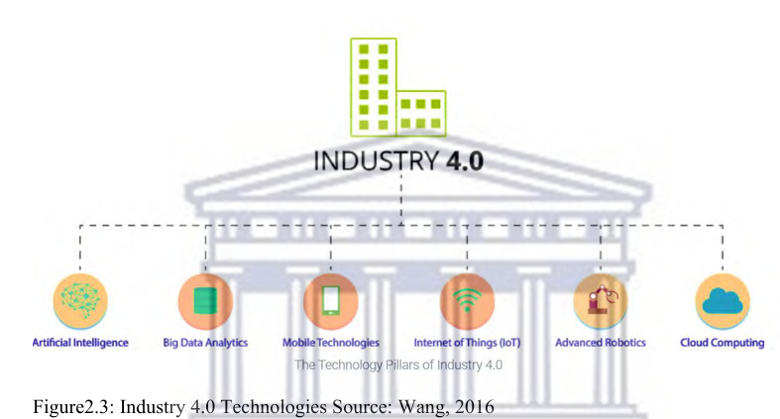

The figure above depicts significant Industry 4.0 technologies and are pioneered as follows:

- Internet of Things (IoT): IoT links many physical items to the internet, enabling smart devices to communicate, monitor, and control goods, services, and information using standard protocols (Wang, 2016).
- Big data analytics: It is a sophisticated analytical method that processes large volumes of dynamic data, offering vital information to improve corporate planning and decision making (Wang, 2016).
- Artificial intelligence (AI): AI is a computer system that enhances human intelligence through data and algorithms, and is widely used in various fields like routing, traffic management, maintenance, and security (Wang, 2016).
- Cloud technologies: They offer a dominant programme for storing and integrating IT resources, facilitating data accessibility from decentralized locations, forming a service-oriented architecture (Wang, 2016).
- Autonomous robots: Autonomous robots are intelligent, self-organizing machines capable of executing tasks without human guidance, available in various sizes, shapes, and the degrees of intelligence, movement, and autonomy (Wang, 2016).
- Mobile Technologies: They are forceful virtual instruments that may efficiently and risk-freely simulate assess, refine, and manage actual systems or things in their digital representation (Wang, 2016).

2.4 Supply Chain Management

Supply chain management (SCM) is widely recognized as a fundamental part of most firms' performance and customer satisfaction. The complexity of supply chains has significantly increased within the previous 20 years because of the dynamic interchange of a variety of processes and structures. Several studies emphasized the significance of supply chain management in a business (Arora & Gigras, 2018).

Table 2.4: Definitions of Supply Chain Management

Authors | Definitions
Mentzer et al. (2001) | SCM entails the interaction of units concerned with the transfer of goods, money, data, and services from a provider to a client.
Grant et al. (2017) | Supply Chain Management refers to the practice of integrating the company's and its suppliers' business processes so that information, goods, and services are made available to customers at an added value.
Bozarth (2008) | Supply Chain Management involves maximizing value for customers and obtaining a practical benefit through the management of relationships and activities across the entire supply chain.
Misra (2018) | The Supply Chain Management process entails synchronizing policymaking and activities so that the correct number of products are delivered to the correct location and customer at the correct time, while minimizing costs and satisfying service requirements.

In summary, strategic SCM aims to increase customer value and preserve a competitive advantage.

2.5 Artificial Intelligence

Artificial intelligence is transforming every aspect of our lives, and the supply chain and logistics sectors are no exception (Kersten, Blecker & Ringle, 2019). The term artificial intelligence does not refer to specific technology. It is a spot-on word for different technological methods (Sharma, Sharma & Jindal, 2021). Artificial intelligence and machine learning are frequently used interchangeably. Machine learning falls under the components of artificial intelligence that describe the velocity and assortment of data sets that are rapidly increasing in size (Sharma, Sharma & Jindal, 2021). In the supply chain spectrum, most firms employ AI to develop novel business strategies and improve overall performance (Toorajipour, Sohrabpour & Fischl, 2021). AI is well-known for its ability to automate processes and actions so that it can run without the need for human interaction. Many uses of AI technology and techniques have grown so prevalent that we may no longer consider them to be AI-based, such as navigation applications, facial recognition and spam filtering, to mention a few (Tai, 2020). The advent of the big data era has resulted in a much broader range of data mining and deep learning technologies in the supply chain landscape. As the size of data grows, data storage and processing are becoming increasingly difficult for businesses as the size of data increases. The broader battle is managing and deriving value from data collected to improve brand strategies and sales (Constantiou & Kallinikos, 2015). AI can analyse huge volumes of data, understand relations, give prominence to operations and support better policy formulation. AI is a potential match marketer (Davenport et al., 2020).

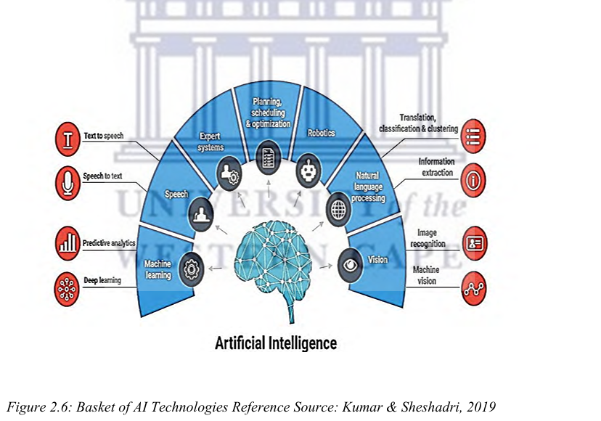

The following are some modern computer approaches and fields of artificial intelligence development that are illustrated in Figure 2.6 above:

Expert System: It refers to a computer-based knowledge management system that enables users to access a database and related information. These systems vary from simple regulatory systems to integrated development systems with vast knowledge bases, inference engines, and user interfaces. With the ability to offer valuable insights and recommendations, expert systems have proven to be a valuable tool for decision-making across different fields. (Kumar & Sheshadri, 2019).

Natural Language Processing: AI aims to teach computers to understand modern languages, with Natural Language being the ultimate generation. Researchers in AI have created a natural language. interface utilizing limited language and composition, analyzing language concepts through linguistic techniques, speech synthesis, machine translation, information recovery, extraction, and speech recognition (Kumar & Sheshadri, 2019).

Pattern Recognition: Pattern recognition is a continuous process in all living beings, involving data collection, pre-processing, character selection, model selection, training, and evaluation. It involves identifying and classifying patterns in a multi-dimensional space (Kumar & Sheshadri, 2019).
Robotics: Robotics, an AI subfield, involves motor and perceptive tasks, utilizing artificial intelligence techniques for automation through human control or predetermined programs (Kumar & Sheshadri, 2019).

Machine learning: It was created in 1959 by Arthur Samuel, an American pioneer in artificial intelligence and computer games. It can be used for supervised, unsupervised, reinforcement, and semi-supervised learning applications. (Kumar & Sheshadri, 2019).

2.5 Current AI Adoption in Supply Chain Management

The adoption of Artificial Intelligence (AI) into supply chain management (SCM) has emerged as a transformative force, enabling organizations to improve efficiency, accuracy, and resilience. AI technologies, including machine learning, natural language processing, and predictive analytics, are increasingly being adopted to optimize supply chain functions such as forecasting, inventory management, logistics, and customer service.

AI adoption in supply chain operations is growing steadily, driven by the need to respond to dynamic market conditions and consumer expectations. According to McKinsey & Company (2021), businesses that have implemented AI in their supply chains have reported cost reductions of up to 15% and service level improvements of up to 35%. This is largely due to AI's ability to analyse vast amounts of structured and unstructured data, uncover patterns, and make accurate predictions in real-time.

One of the primary applications of AI in SCM is demand forecasting. Traditional forecasting methods often fail to account for volatile consumer behavior and external factors such as weather or economic shifts. AI-driven forecasting models can incorporate a wide range of data sources including sales history, social media trends, and market indicators to provide more accurate and responsive predictions (Deloitte, 2023). This allows companies to reduce stockouts and excess inventory, thereby improving overall supply chain agility.

Another significant area of AI application is in inventory and warehouse management. Machine learning algorithms help determine optimal stock levels and reorder points by continuously analyzing sales patterns and lead times. In warehouse settings, AI-enabled robots and automated systems assist in picking, sorting, and packing tasks, enhancing both speed and accuracy (Gartner, 2022). This automation also reduces human error and labor costs while increasing throughput.

AI is also transforming logistics and transportation management. Through real-time data analytics and route optimization algorithms, AI systems can determine the most efficient delivery paths, anticipate disruptions, and adapt accordingly. For instance, companies like DHL and UPS have incorporated AI tools to improve route planning and fuel efficiency, which has led to significant cost savings and improved delivery timelines (PwC, 2021).

Moreover, AI is increasingly used for predictive maintenance of equipment and vehicles within the supply chain. By using IoT sensors and machine learning models, organizations can predict equipment failures before they occur, thus reducing downtime and maintenance costs (Accenture, 2020). This proactive approach to maintenance enhances operational continuity and asset utilization.

2.2 AI in a Supply Chain Management Context

The numerous challenges that were experienced during the COVID-19 pandemic meant the fast tracking of growth for supply chains. Some of the 16 challenges included lack of flexibility and diversification, and reduced efficiency in supply, transport, and production (Dale, 2022). Technology has played a critical role in addressing these challenges and improving supply chain resilience. By leveraging core technologies such as cloud computing, blockchain, and big data, companies have been able to enhance information sharing and improve data accuracy

These have enabled supply chain management to be more transparent and have allowed for the capability to track, monitor and maintain inventory levels effectively. It has also allowed for the optimisation of routes while balancing demand. Other technologies like IoT as well as AI and machine learning have also been instrumental in supply chains management being able to mitigate risks during the pandemic. One such example is the utilization of IoT devices that is utilized for the collection of real-time data and processing this data into concrete information for supply chains to make real-time decisions and prevent waste (Ilatova et al., 2022). AI and machine learning together have been shown to be effective in supply chains.

These technologies can provide useful insights, trends and predictions which mitigates potential risks. This is important for supply chain management as it essentially delivers the potential to forecast the future through the use of technology (Nasser, 2021). In combination with other technologies, these ensure supply chains eliminate more waste and become leaner in operations. This, by extension, results in more competitive supply chains, though the challenge with this is maintaining this. Supply chains were previously operations-focused; this has also progressed to having an element of digital skills (Alick et al., 2020). Technology has provided supply chain firms with the strength to face any upcoming challenges that are offered following the pandemic.

Over the years, there have been quite a number of AI developments for supply chain management. Among these developments is the use of AI-based robots to optimize production and efficiency in supply chain operations. Organizations such as Amazon and Alibaba have been able to integrate AI-powered robots within their warehouses to improve the efficiency and accuracy of order picking (Ehioghae & Idowu, 2021). The robots utilize AI algorithms to streamline routes, reduce errors and improve the overall productivity of the supply chain process. This also equates to a safer environment, thanks to the sensors (IoT) and Artificial Intelligence, since the robots can prevent collisions within the warehouse (Ehioghae & Idowu, 2021).

One other important innovation in AI for supply chain management is the use of data that has been gathered from different systems, including Enterprise Resource Planning, Customer Relationship Management, Manufacturing Execution Systems, Supplier Relationship Management, and Supply Chain Management systems. The data is integrated through the use of a golden thread and can give distinctive insights into the supply chain process (Awan et al., 2021).

AI has the potential to transform supply chain management in numerous ways. One of the greatest benefits of AI in supply chain management is that it has the ability to analyse data from diverse sources and provide insightful information (Dora et al., 2021). Such insights are capable of furnishing organizations with the information required for making educated choices that reduce the risk factor (Xu et al., 2022). An example is the application of AI in forecasting inventory and demand to improve planning by taking proactive and agile decisions (Xu et al., 2022). By applying AI algorithms, decision makers in supply chains can make more accurate forecasts about demand patterns to adjust inventory levels accordingly (Xu et al., 2022).

This active inventory management can lower costs and limit the possibility of low stocks or overstocking. Furthermore, AI can provide supplier choice by anticipating the reliability of suppliers (Xu et al., 2022). This predictive nature of AI provides supply chain managers with greater assurance in decisions relating to with whom to transact in regard to delivery performance, product quality, and prices. In addition to demand forecasting and vendor selection, AI is even capable of optimizing supply chain networks (Hassan Younis et al., 2021). Hassan's paper explores how AI and machine learning have the potential to positively influence supply chains although if an organisation does not possess the skills and foundation necessary this will hinder an organisation. By examining customer demand patterns, transport routes, and supplier information, the most efficient supply chain configurations can be calculated by AI algorithms. Such optimized configurations can have the capacity to streamline processes, cut costs, eliminate waste, and maximize the overall efficiency of the supply chain. AI can also become a valuable warehouse management tool by optimizing order picking and inventory location operations. By analysing product demand, warehouse capacity, and order frequencies, AI algorithms are able to compute the optimal placement of inventory within a warehouse (Bag et al., 2023). This can minimize travel time and increase order fulfilment rates.

2.3 Evolution of adoption of AI in Supply Chain Management

AI and machine learning are still in their early days but already there have been high levels of success (Hassan Younis et al., 2021). AI can give supply chain management the competitive edge by reducing the bull whip effect (Hassan Younis et al., 2021). AI has evolved in supply chain management built from machine learning and big data analytics. This has helped supply chain management to achieve efficiency and quality improvement (Hendriksen, 2023).

Mckinsey and co reported that early adopters of AI have reduced their logistics costs by 15% and inventory levels by 35% compared to those who were slow to react (Alick et al., 2022). One area where AI can make a big impact is in demand monitoring and forecasting. By analyzing large sets of historical data, AI algorithms can find patterns and trends that humans miss (Jakovlev et al., 2021).

Humans will look back at historical data and try to add some predictions to model a forecast. AI can use historical data as well as add the component of future predictions, like weather patterns or pending conflict based on being able to use more sources of data (Mohsen, 2021). Another area where AI can make a contribution is in selecting suppliers by predicting supplier reliability. And AI can improve warehouse management by optimizing inventory placement and order picking processes

2.4 Limitations of AI in Supply Chain Management

Despite numerous benefits and prospects for AI in supply chain management, there are constraints and problems as well that must be brought into account. One of the challenges faced in using AI is the quality of data. AI algorithms require complete, accurate and comprehensive data in order to be able to provide concrete credible outputs (Ehioghae & Idowu, 2021). Furthermore, incorporation and implementation of AI technologies into current supply chain infrastructure can be complicated and involve huge investment in the form of time and resources (Hangl et al., 2023).
Figure 2.1 illustrates the highest level of education in the world and, if we look at South Africa, the level of education is not high enough to apply skilled labor to implement AI. South Africa has the lowest tertiary education rates according to the study below. Low education has a positive relationship with unemployment (Jeza et al., 2023).

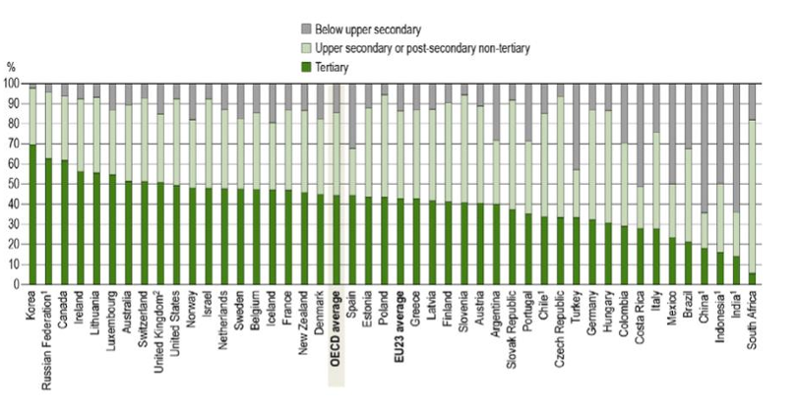

Figure 3: Educational attainment of 25–34-year-olds (2022)
Source: Education at a Glance:2019

Although AI has the potential to transform supply chain activities, its implementation and complete integration within supply chain systems is still in its embryonic stage (Ngetich et al., 2022).

Nevertheless, as a growing number of companies recognize the advantages of AI in supply chain management, increasingly more adoption and innovation in this area can be anticipated. Wang and Pan (2022) outlined the determinants of AI adoption and supply chain resilience induced by AI. Three determinants, namely enterprise AI technology, supply chain collaboration, and environmental uncertainty are the three elements that significantly influence AI technology adoption. The three elements, in a balance, positively influenced supply chain resilience. The study was carried out particularly in emerging economies (Wang & Pan, 2022). AI has a number of limitations in its application in supply chain management despite its potential advantages. One of its most significant limitations is the absence of strong and credible data.

This means data becomes part of a crucial requirement. But in supply chain management, there are issues with the data, i.e., data may be incomplete (this may be due to the fact that data is manually entered), data may be of low quality and inconsistent. Data may be dispersed among various systems and various sources which makes it problematic to extract and consolidate the necessary information (Yang & Wang, 2021). One other reason adoption is challenging is the dynamic supply chain activities. Supply chains are dynamic and constantly changing, it is challenging for AI systems to adapt quickly and effectively (Ehioghae & Idowu, 2021).

Another limitation is the lack of transparency and interpretability of AI algorithms (Awan et al., 2021). Though AI algorithms can process data, recognize patterns, and give insights, their internal processes are widely regarded as a "black box.". This absence of transparency impedes supply chain managers from knowing how the AI system arrives at its recommendations or predictions (Ngetich et al., 2022).

In addition, AI systems are untrustworthy when dealing with uncertainty and unforeseen circumstances.

For example, AI algorithms may be unable to forecast sudden demand changes, supply chain interruptions, or unforeseen market conditions. In addition, AI technology can require enormous investment in terms of financial resources and infrastructure (Dunayev et al., 2022). For adopting and implementing AI, significant effort and time will be required. This will be needed for system integration and training.

Lastly, ethical problems along with biases in AI algorithms can also place limits on supply chain management (Jacobs et al., 2021). This is a tremendous issue that continues to plague the use of AI in many instances. A McKinsey and Co report noted that the common problems experienced by the respondents in using AI were:

  - 45% of the respondents noted that a project was not delivered on time.
  - 26% said it exceeded the budget.

The top 3 listed risks were:
- Change management (82%)
- Poor process design (70%)
- Missing capabilities (57%)

The above highlights a skills gap in deploying AI. A paper by Hamed Nozari identified lack of proper infrastructure and cybersecurity impacting AI in fast moving consumer goods (FMCG) environments (Nozari et al., 2022). This speaks to the environment in which the supply chain exists. In South Africa, a report by Accenture complied in 2020 noted that South Africa had the third highest number of cybercrimes worldwide (MCANYANA et al., 2020).

2.5 Policies impacting AI adoption in South African Supply Chain Management

South African supply chains have faced challenges in how to move both domestic and international freight efficiently and effectively (Luke & Heyns, 2022). This is caused by a number of things, such as deteriorating infrastructure, expensive logistics, and low operational efficiency. As of November 2023, South Africa is working on guidelines, and talks on possible AI regulations are still ongoing (Technologies, 2023). It will be necessary for South Africa to create regulations and rely on professionals in the field. The regulations should ensure that AI is developed responsibly and provide incentives for companies to invest in this field (Paul et al., 2023).

In addition to regulatory uncertainties, the lack of clear policy frameworks has created ambiguity for businesses seeking to adopt AI in supply chain operations. The absence of standardized data governance policies, cybersecurity protocols, and ethical AI guidelines has made it difficult for supply chain actors to fully trust and integrate AI solutions into their processes. According to Mahlangu and Mofokeng (2021), digital transformation in South Africa’s supply chain sector requires the establishment of cohesive digital policies that align with broader national development goals. Without such policies, companies risk misalignment with future legal mandates or ethical expectations, potentially undermining both innovation and public trust.

Furthermore, the success of AI adoption in supply chains is highly dependent on public-private collaboration. Policymakers need to work closely with industry leaders, academic institutions, and technology developers to co-create frameworks that are both practical and future focused. As highlighted by Mhlanga (2023), collaborative ecosystems enable a shared understanding of technological risks and benefits, which can help foster responsible AI deployment. These partnerships can also bridge gaps in technical capacity by offering training initiatives and access to innovation hubs that support the development of AI competencies in the logistics and supply chain sectors.

Lastly, incentives and infrastructure investment will play a pivotal role in accelerating AI integration. Government led initiatives, such as tax incentives for AI R&D and funding support for small and medium-sized enterprises (SMEs), can lower the barriers to entry for AI technology. According to Paul et al. (2023), incentivising innovation through grants and subsidies can enhance competitiveness and stimulate widespread technological adoption across the supply chain ecosystem. At the same time, upgrading digital and physical infrastructure such as 5G connectivity and smart transportation networks will be essential to realizing the full potential of AI applications in tracking, inventory management, and predictive analytics.

2.6 Technology infrastructure in South Africa

Infrastructure is essential for supply chains to advance and integrate AI. Implementing AI will be difficult due to South Africa's current infrastructure (Gwagwa et al., 2021). Although there is a shortage of institutional capacity, South Africa has well-established government entities that can create plans for the development and application of AI (Awan et al., 2021). Additionally, the public sector is underfunded, which impedes the advancement of AI (Chilunjika et al., 2022). As was indicated in earlier sections, South Africa can advance by creating frameworks for rules and regulations that will promote growth and sustainability in the adoption of AI. In order to access advanced computational resources, high-speed internet connectivity is required (Ghouati et al., 2022).

Another significant obstacle to AI implementation in South African supply chains is the digital divide between urban and rural areas. While metropolitan regions such as Johannesburg and Cape Town have relatively better access to high-speed internet and digital infrastructure, rural and peri-urban areas continue to experience limited connectivity and inconsistent power supply (Chilunjika et al., 2022). This disparity hinders the equitable adoption of AI technologies across the supply chain network, limiting opportunities for small and medium enterprises (SMEs) operating in less developed regions. Addressing this imbalance will require a targeted investment strategy aimed at expanding broadband infrastructure and ensuring reliable electricity access throughout the country.

Moreover, AI technologies require robust data collection and storage systems, yet South Africa’s digital infrastructure lacks the necessary scalability and resilience to support large scale data processing. Gwagwa et al. (2021) point out that existing ICT infrastructure in many sectors is outdated and fragmented, making it difficult to integrate AI-driven tools such as predictive analytics, smart routing, and automated decision-making systems. For AI to become a transformative force in supply chains, there needs to be a concerted effort to modernize ICT systems, adopt cloud computing solutions, and establish secure data centres capable of handling big data workloads efficiently and ethically.

Collaborations between the government, private sector, and international partners could help overcome some of these infrastructural limitations. According to Awan et al. (2021), public-private partnerships can mobilize both financial and technical resources necessary for upgrading infrastructure. These partnerships could also support capacity-building programs to train professionals in managing and operating AI systems. In this regard, national strategies such as South Africa’s draft AI policy and the broader Fourth Industrial Revolution (4IR) initiatives present an opportunity to align infrastructural development with long-term economic and technological goals. By investing in resilient digital infrastructure, South Africa can position its supply chain sector to fully leverage AI for improved efficiency, transparency, and competitiveness.

2.7 Social perceptions of AI in South African supply chain management

There are mixed views on AI. There is one view of the benefits of deploying AI, efficiency, cost reduction, threat identification and reaction time. On the other hand, there is uncertainty around deployment and job security (Abhinav Hasija, 2022; Hasija & Esper, 2022). In a country with high unemployment and lack of skills is particularly relevant (Gwagwa et al., 2021). There is also the issue of trust, human labour is more trustworthy than AI (Venkatesh, 2021). The unexplored topic is income equality, this is interesting as there is concern around job displacement but there should also be concern around income equality (Martens & Tolan, 2022). If AI is assisting with jobs does this mean employee costs will be reduced? A report by Mckinsey and company indicates how digitisation and automation could create 1.2 million jobs by 2030. This was across all industries in South Africa.

In the context of South Africa’s socio-economic landscape, these mixed perceptions of AI are deeply intertwined with the broader issues of inequality and historical marginalization. While AI promises operational efficiency and the potential for job creation through new digital roles, there remains significant concern that these benefits may be unevenly distributed. According to Gwagwa et al. (2021), the digital divide and disparities in digital literacy could result in AI-driven opportunities being accessible only to a small, skilled elite, thereby reinforcing existing inequalities. This concern is particularly pressing in supply chain industries, where many workers hold manual or semi-skilled positions that are most vulnerable to automation. Thus, without proactive upskilling and inclusive policy interventions, AI may exacerbate income inequality and economic exclusion rather than alleviate them.

The report further stated that there will be demand for 1.7 million graduates specialising in technology in South Africa, so universities and industry need to align programmes with the needs that will be required for industry (Nomfanelo Magwentshu 2022).

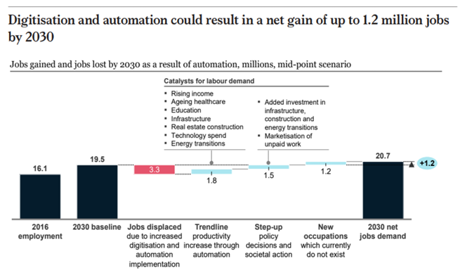

Figure 4: Jobs gained and lost through automation by 2030
Source: Stats SA, ONET, Oxford Economics, McKinsey Global Institute analysis (Co, 2019)

2.8 South African skill levels and the impact on employment

There is a direct correlation between unemployment rates and the skill levels in South Africa (Christopher, 2015). Technology advancements have meant that there is need for a new skill type. When skills become outdated, more people find themselves without jobs as they do not meet the requirements (Omar et al., 2022). This will lead to higher unemployment rates (Charl & Fatima, 2022). The challenge that exacerbates the problem is that South African education organizations do not provide the necessary skills that are required (Samuel & Thakhathi, 2021). This then causes a mismatch between the skills needed in the workforce versus those that are out there (Christopher, 2015).

To tackle this mismatch, there needs to be an intervention to align the two, so that the required skills are available. This in turn will assist in lowering the unemployment rates in South Africa (Charl & Fatima, 2011). There also needs to be promotion of lifelong learning, so skills remain up to date as technology advances (Charl & Fatima, 2023). Recently, institutions have developed courses that are technology related and specifically AI related to upskill employees (Kiemde & Kora, 2021). A report by released by Mckinsey & Companympany highlights the requirements for South Africa to be able to take advantage of digitization within the country (Nomfanelo Magwentshu 2019). This was divided into three categories, national, business and personal. The below talks to how digitization needs to be adopted between a collaborative approach between Government and Business.

- Government – Government needs to embrace digitization by investing in human capital. There need to be solutions found for the impact of automation on jobs.
- Business – Business will need to rethink strategy, as to include digitization. The workforce will need to be upgraded by planning and upskilling the workforce. There needs to be a change of management to embrace the new ways of working.

From the above, it is evident that there is a need for South Africa and South African business to adapt to the disruption of technology. South Africa’s high unemployment leads to higher levels of inequality (Nomfanelo Magwentshu 2022).

2.10 AI as a strategy in supply chain management

According to the literature, supply chains are increasingly focusing on artificial intelligence. DHL is one of the leading supply chain companies in the world. This is shown in the Logistics Radar report released by DHL (Dalsey, Hillblom and Lynn). The report looks at the trends in the logistics industry and a large part of the trends are now looking at technology (DHL, 2022). One of the concepts to understand if organizations are ready to take on technology is Digital Maturity. This essentially is the measure of an organization’s ability to obtain specific strategic and operational organizational results within the use of technological change. Therefore, it measures where an organization is on the digital transformation journey (Armstrong & Lee, 2021). Organizations need to understand this factor in where they are on the journey. This will give companies the opportunity to benchmark where they are and where they intend to be, to bridge the gap. One of the models used to understand this is Westerman’s ‘Leading Digital’ Model.

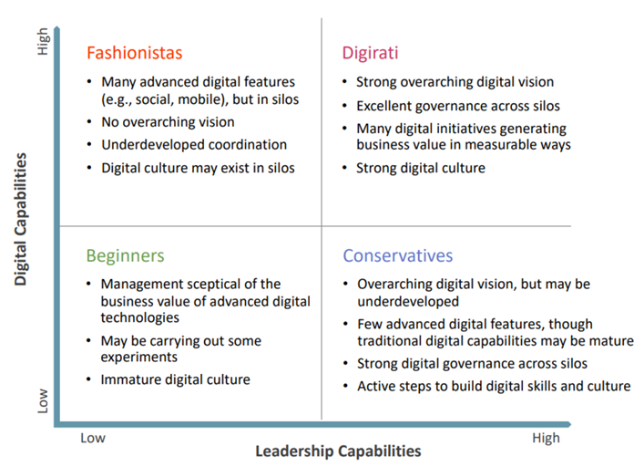

Figure 5: Westerman representation of Digital Maturity
Source: Westerman 2014

Westerman representation shows both digital capabilities and leadership capabilities and then ranks where on the graph companies are based on characteristics. Westerman’s model also comments that there is a correlation between higher levels of maturity and organization performance, between revenue and profitability (Westerman et al., 2014). The model speaks of the different journeys that organizations find themselves in. In the lower left-hand side, there are beginners, still in the infancy of adoption. The top left-hand side, where the organizations have advanced digital skills, although there is lack of cohesion. The bottom right-hand side of the quadrant, where the strategy is strong, with strong governance across the organizations for the adoption of technology, although the technology is still in the infancy. The top right-hand side speaks to the digirati, organizations who have strong technological skills coupled with a strong vision and governance.

2.11 Current trends in AI in supply chain management

As previously noted, the pandemic has hastened the adoption of AI in supply chain management (Hangl et al., 2022). There are numerous organizational and developmental obstacles to AI adoption (Dora et al., 2021). Effective planning and development are necessary for the successful deployment of AI. Furthermore, the adoption of AI has been slow in certain supply chain businesses (Riahi et al., 2021). The decision to implement AI is also influenced by technological and environmental obstacles (Hassan Younis et al., 2021). The use of other technologies has been facilitated by the improvements in supply chain software in recent years (Awan Usama & Ajantha, 2021). Supply chains will see the need to evolve and will eventually find ways to overcome these barriers, although in the current state it is still in its infancy.
Recent trends indicate a growing interest in the adoption of AI with complementary technologies such as the Internet of Things (IoT), blockchain, and cloud computing to enhance supply chain visibility and resilience. These integrated systems enable real-time tracking, predictive maintenance, and data-driven decision making, which are essential in managing complex logistics networks (Dora et al., 2021). For example, AI-powered predictive analytics, when coupled with IoT sensors, can forecast demand fluctuations and adjust inventory levels, accordingly, reducing both waste and stockouts. This convergence of technologies is steadily transforming traditional supply chains into smart, adaptive networks capable of responding to dynamic market conditions.

Despite this progress, a significant number of organizations remain hesitant to fully commit to AI adoption due to concerns around cost, data security, and a lack of skilled personnel. As highlighted by Hangl et al. (2022), many firms, particularly in developing economies, perceive AI implementation as a high-risk investment with uncertain returns. These concerns are compounded by the need for data transparency and ethical considerations, especially when AI systems are involved in decision-making that affects employment or customer service. Addressing these concerns requires not only technical solutions but also the establishment of trust through clear regulatory frameworks and robust data governance policies.

Looking ahead, the trend toward AI adoption in supply chains is expected to accelerate, driven by competitive pressures and the need for operational efficiency. Companies that have already begun experimenting with AI are likely to scale up their efforts, particularly in areas such as warehouse automation, route optimization, and supplier risk assessment (Hassan Younis et al., 2021). As Awan Usama and Ajantha (2021) point out, advancements in supply chain software are making it easier for firms to integrate AI without having to overhaul their entire IT infrastructure. With increased investment in digital skills development and technology infrastructure, the barriers to AI adoption are gradually being lowered, positioning supply chains for a more data-driven and agile future

2.12 Future trends in AI in supply chain management

In the future, it is anticipated that AI will continue to play a pivotal role in supply chain management. AI has the potential to optimise many of the current supply chain processes such as demand forecasting, inventory management and logistics optimisation, these will also grow further. AI is still a growing technology, there are advancements in natural language processing capabilities and machine learning, this will then enable AI to better understand but also interpret unstructured data such as customer reviews, social media sentiments, and market trends (Kamble et al., 2021).

AI is transforming the supply chain management landscape by improving planning and decision-making processes, enhancing inventory forecasting and demand prediction accuracy. Furthermore, AI has the potential to enable end-to end visibility across the supply chain, facilitating real-time tracking and monitoring of goods and shipments. AI is expected to take off in supply chain, with enhanced capabilities for demand forecasting, inventory management and understanding unstructured data.

AI will not just benefit from the optimisation and efficiency that AI will bring to the supply chain industry, but it will change the landscape of competitiveness (Bag et al., 2023). A survey done on healthcare supply chain executives showed that AI’s impact will be on significantly improving the operational efficiencies in the supply chain (Bag et al., 2023). South African supply chains will become more cost effective and will have many opportunities for value creation. This in turn will put South Africa in a better standing on the global stage. This will enable South Africa to be more competitive (Tzachor et al., 2014).

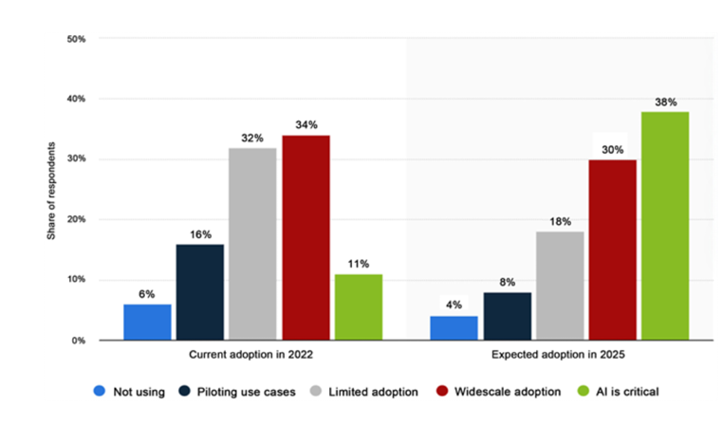
Figure 7: Global AI adoption rate in supply chain and manufacturing businesses (2022 and 2025)
Source: Statista (2022)

Figure 3 shows the rate of AI adoption in supply chain and manufacturing. The data shows that AI will become critical in the coming years - an increase of 27% in 3 years where AI will be critical. Widescale adoption decreases although that can be accounted for by the increase in AI and this is critical.

The below figure from a McKinsey and Co report shows how the future landscape of supply chain management could look with the assistance of AI. This will result in more proactive decision making for supply chains, as AI will enable integrated solutions (Alick et al., 2020).

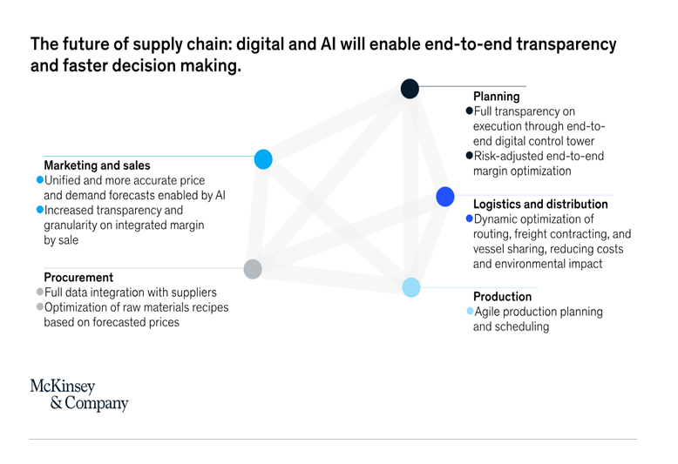

Figure 8: The future of supply chain
Source: Mckinsey and Company 2022

Based on the logistics trend radar report 6.0 (a report released by DHL every 2 years), the below shows that Interactive AI will see realisation in the next 5 years and will have a high impact. DHL is a global player in the logistics industry and one of the top supply chain companies in the world (DHL, 2022).

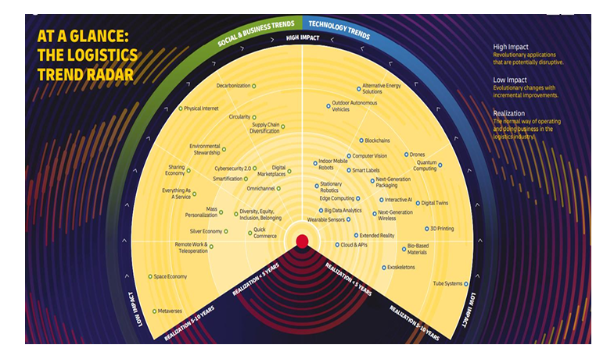
Figure 9: The Logistics Trend Radar
Source: DHL The Logistics Trend Radar Report 6.0

DP (Dubai Ports) World another world leading supply chain company, sees AI as a crucial part of its company. Pradeep Desai who is the Chief Technology Officer at DP World spoke on his blog as to how DP World uses AI in their terminals. The software does roster of staff to streamlining customer inspections (which use to be a long intensive process), the AI-driven software creates and then applies solutions (that are practical) for the terminal to operate (Desai, 2023). This shows how supply chain companies are embracing AI and how it is becoming fundamentally important to give higher levels of customer satisfaction.

CHAPTER 3: METHODOLOGY

3.1 Introduction

The section outlines the study's methodology which describes how the study was conducted to meet the objectives. The research methodology discusses philosophy, strategy, approach, methods of the research and the data analysis. This describes how data were gathered and used. The research technique provides a profound insight into the factors influencing the adoption of AI in the South African supply chain and logistics business.

3.2 Research design

Research design describes the journey that the investigator chooses to follow during the research road to finding answers to the research (Walsham, 2014). This study adopts qualitative research design.

3.2.1 Qualitative Resign Design

Leedy and Ormrod (2019) described qualitative research design as an informative and realistic approach that focuses on studying phenomena in their natural context to advance in the experiences and perspectives of people. Unlike quantitative research, qualitative research does not rely on numerical values and models to present findings. Rather, it is concerned with gaining a deep understanding of complex situations and interpreting the meanings attached to them. Merriam (2019) further explained that qualitative research employs theories to elucidate and comprehend events and phenomena and generate new theories. Qualitative methods are especially suited when researching an unfamiliar topic, examining the inner perspectives of participants, or when the focus is on exploring a particular perspective or experience. To collect data, qualitative research relies on three main sources: interviews, observation, and documents.

3.3 Research strategy

The various research strategies used in the research study will include survey. A survey refers to the form of data collection that is widely used by researchers to obtain vast volumes of data from a limited number of people on a given subject. This method of data collection is often used to capture quantitative data (DuBenske et al., 2014).

3.3.1 Survey

Survey research refers to the technique of gathering data that entails questioning a sample of people
in order to obtain information the technique of gathering data that entails questioning a sample of people in order to obtain information. (Check & Schutt, 2012). This type of research allows for flexibility in participant recruitment and data collection methods. In survey research, one can employ qualitative research techniques like open-ended questions or quantitative techniques like statistically scored items, or a mix of the two. Due to their ability In social and psychological research, surveys are frequently used to characterize and investigate human behavior. (Singleton & Straits, 2009). For many years, survey research has been used to gather information from both individuals and groups. It can take many forms, from straightforward focused questions to more involved studies involving the use of numerous legitimate and trustworthy instruments. A few instances of surveys that are less rigorous are public opinion and marketing surveys, which also look at consumer behavior. The literature was carefully reviewed, and then data were gathered using a quantitative approach that involved the use of a survey. The questionnaire for the study was developed by the TOE Framework (Mariemuthu, 2019; Ghazilla et al., 2015; Doherty et al., 2013).

3.4 Data Collection

To reach the appropriate target, surveys links will be sent the survey to prospective target link via the LinkedIn website in order to conduct an online survey. (www.LinkedIn.com). The online questionnaire will be available for completion from 1st July 2025 to 30th July 2021. LinkedIn was chosen as a platform for distributing the survey due to its large professional user base and the ability to target specific industries and job titles. The survey is intended to gather data on various aspects linked to the participants' professional experiences and opinions. The responses collected through the online questionnaire will be analyzed to draw meaningful insights and conclusions.

In total, 200 individuals will be selected from the South African LinkedIn. These individuals would come
from various levels in the supply chain and logistics sector. Using the handy sample technique, all
respondents will be contacted by emailing the survey link to possible respondents via the www.LinkedIn.com network. Convenient sampling is an approach in which the investigator picks participants based on their availability and the features that the researcher desires to investigate (Creswell, 2012). Data will be analysed using SPSS ((Statistical Package for the Social Sciences).

3.5 ETHICAL DECLARATION

As a result, the information collected to create this study is stated to be the author's original work. Therefore, the author has noted and properly quoted the work of those cited in this study. The author adhered to the highest ethical principles when working on this study. Participation in the research would remain private, anonymous and most importantly it will be voluntary. The respondents will have the freedom to get out of the activity at any time should they wish to do so. Respondents will be requested to complete a consent form, and the form detailed all the information about the research. The principle of consent is to ensure that the respondent fully understands the implications of participation and freely gives the decision about whether to do so, without the exercise of any pressure or coercion.

3.6 DELINEATION,

This report investigates the impact of Artificial Intelligence (AI) on supply chain management in South Africa, with a specific focus on policy implications, infrastructure readiness, and current adoption trends. The report aims to assess the opportunities and challenges posed by AI technologies in enhancing supply chain performance. It will analyze existing literature, evaluate government and private sector initiatives, and propose recommendations to facilitate responsible and effective AI adoption. Key themes include regulatory frameworks, technological infrastructure, organizational readiness, and the integration of complementary digital tools.

3.7 TIMELINE

The timeline below outlines the phased approach that will be followed to complete the report by the final hand-in date of 10 October 2025:
Phase | Activities | Timeline
1. Topic Confirmation | Finalize topic, define scope, and consult supervisor | 20–24 May 2025
2. Literature Review | Conduct in-depth review of academic sources and industry reports | 25 May – 10 June 2025
3. Outline Development | Draft detailed structure and organize key sections of the report | 11–15 June 2025
4. Initial Drafting | Write initial sections (Introduction, Background, and Literature Review) | 16 June – 5 July 2025
5. Core Analysis | Develop main analysis sections (Policy, Infrastructure, Trends) | 6–31 July 2025
6. Recommendations | Formulate recommendations and discuss future implications | 1–10 August 2025
7. First Full Draft | Compile all sections into a complete draft and self-review | 11–20 August 2025
8. Peer/ Supervisor Review | Submit to peers/supervisor for feedback and conduct revisions | 21 August – 10 September 2025
9. Final Editing | Proofread, refine formatting, ensure citation consistency | 11–25 September 2025

3.8 SIGNIFICANCE

The adoption of Artificial Intelligence (AI) in supply chain management holds substantial potential for transforming operational efficiency, cost-effectiveness, and responsiveness across various industries in South Africa. This research is significant because it addresses a timely and critical need to understand how AI technologies can be responsibly and effectively integrated into supply chains amid infrastructure limitations, regulatory uncertainty, and economic challenges.

The findings of this research will benefit multiple stakeholders. Supply chain professionals and logistics companies will gain insights into overcoming technological and organizational barriers to AI adoption. Policy makers and government entities will benefit from recommendations on developing regulatory frameworks that support innovation while ensuring ethical and equitable AI use. Furthermore, technology providers and software developers can use the findings to better tailor their AI solutions to the specific needs of the South African context.

Industries such as manufacturing, retail, transport and logistics, and agriculture stand to benefit the most from this research. These sectors are heavily reliant on supply chain efficiency and can leverage AI to optimize processes like demand forecasting, inventory management, route optimization, and real-time tracking. Ultimately, the research contributes to national objectives such as economic growth, digital transformation, and inclusive industrial development by highlighting AI’s strategic role in modernizing supply chain systems in South Africa

1.10 Bibliography

- Accenture. (2020). AI in Supply Chain: Transforming Business Performance.
- Agarwal, P., Malhotra, S. K., & Swami, S. (2024). The role of smart technologies in managing supply chain post pandemic: an exploratory scientific procedures and rationales for systematic literature review. Journal of Science and Technology Policy Management, ahead-of-print(ahead-of print).
- Alick, K., Azcue, X., & Barriball, E. (2021). Supply-chain recovery in coronavirus times. McKinsey & Co.
- Alick, T., Johnson, R., & Peters, M. (2021). AI-driven efficiencies in global retail supply chains: A case study of Walmart. Journal of Supply Chain Innovation, 8(3), 45–59.
- Awan, I., Mhlanga, D., & Dunga, H. (2021). Public sector readiness for AI adoption in Africa. Journal of Technological Advancement and Policy.
- Bag, S., Dhamija, P., Singh, R. K., Rahman, M. S., & Sreedharan, V. R. (2023). Big data analytics and artificial intelligence technologies based collaborative platform empowering absorptive capacity in health care supply chain: An empirical study. Journal of Business Research, 154, 113315.
- Deloitte. (2023). AI-Driven Supply Chains: The Future of Intelligent Logistics.
- Department of Communications and Digital Technologies. (2023). Draft AI Policy Framework. Pretoria: Government of South Africa.
- Desai, K. (2023). AI in action: Transforming logistics in South Africa. South African Journal of Logistics and Technology, 12(1), 78–90.
- Desai, P. (2023). How AI is transforming global trade possibilities. DP World
- Felea, M., & Albastroiu Nastase, I. (2013). Defining the Concept of Supply Chain Management and its Relevance to Romanian Academics and Practitioners. Amfiteatru Economic, 15, 74-88.
- Gartner. (2022). Market Guide for AI Applications in Supply Chain.
- Gwagwa, A., et al. (2022). AI deployments in Africa. African Journal of Information and Communication
- Gwagwa, A., Kazadi, N., & Mkhize, B. (2022). The state of AI readiness in South African higher education institutions. African Journal of Technology and Society, 6(2), 101–117.
- Hangi, J., et al. (2023). Barriers to AI Adoption in SCM. Technology in Society, 74.
- Hirsch, K., Niemann, W., & Swart, B. (2024). Artificial Intelligence and Information Systems Capabilities for Supply Chain Resilience. Journal of Transport and Supply Chain Management, 18, a1025.
- Ittmann, H. W. (2015). The impact of big data and business analytics on supply chain management. Journal of Transport and Supply Chain Management, 9, 1-9.
- KPMG. (2022). AI and the Future of Supply Chain.
- Kruger, L., & Luke, R. (2024). Data challenges in South African warehouses. South African Journal of Logistics and Technology, 12(1), 78–90.
- Luke, R., & Heyns, G. (2022). Freight logistics in South Africa: Policy, challenges, and opportunities. Journal of Transport and Supply Chain Management.
- Mahlangu, P., & Mofokeng, T. (2021). Digital transformation in South African logistics: Enablers and barriers. South African Journal of Business Management.
- McKinsey & Company. (2021). The Rise of AI in Supply Chain Management.
- Mhlanga, D. (2023). Artificial intelligence in South Africa: Challenges, prospects, and regulatory considerations. Journal of African Policy Studies.
- Mishra, O. P., Kumar, V., & Garg, D. (2013). JIT supply chain; an investigation through general system theory. Management Science Letters, 3, 743-752.
- Molopa, T. (2023). Factors Affecting the Adoption of Artificial Intelligence in the Supply Chain
- Naidoo, L. (2024). Post-pandemic digital transformation in South African supply chains: Challenges and opportunities. Journal of African Economic Systems, 15(1), 22–38.
- Naidoo, P. (2024). The Adoption of AI in the South African Supply Chain Industry. University of the Witwatersrand.
- Paul, M., Sithole, K., & Govender, R. (2023). Policy and innovation: Fostering AI development in emerging economies. Technology and Development Review.
- Pillay, P. & Mafini, C. (2023), ‘Supply chain bottlenecks in the South African construction industry: Qualitative insights’, Journal of Transport and Supply Chain Management 11(0), a307
- PwC. (2021). AI in Logistics: Building Smarter Supply Chains.
- Russell, S., & Norvig, P. (2020). Artificial Intelligence: A Modern Approach (4th ed.). Pearson.
- Scholten, K., Scott, P. S., & Fynes, B. (2014). Mitigation Processes— Antecedents for Building Supply Chain Resilience. Supply Chain Management, 19(2), 211-228.
- Stats SA. (2023). Quarterly Labour Force Survey: Q4 2023. Statistics South Africa. https://www.statssa.gov.za/
- Technologies, A. (2023). AI regulation in South Africa: Current debates and future directions. South African ICT Policy Digest.
- Technologies, D. o. C. a. D. (2023). Minister Mondli Gungubele: Artificial Intelligence Expo Africa 2023.
- Wang, M., & Pan, X. (2022). Drivers of AI in Supply Chain Resilience. Sustainability, 14(24), 16836.
- Wang, M., & Pan, X. (2022). Drivers of Artificial Intelligence and Their Effects on Supply Chain Resilience and Performance: An Empirical Analysis on an Emerging Market. Sustainability, 14(24), 16836. https://doi.org/10.3390/su142416836.
- Wang, Y., & Pan, L. (2022). The impact of AI technologies on global supply chain performance: A review and outlook. International Journal of Supply Chain Management, 11(4), 115–130.
- Yuen, Y. Y. (2024). Artificial Intelligence in Supply Chain Management: A Comprehensive Review and Framework for Resilience and Sustainability. International Journal of Supply Chain Management, 11(4), 115–130.
- Chilunjika, A., Mutanga, T., & Nhemachena, C. (2022). Infrastructure and innovation capacity in Southern Africa. African Journal of Public Affairs.
- Ghouati, A., Ranjit, J., & van Zyl, J. (2022). Connectivity as a catalyst for AI in African supply chains. Journal of Emerging Technologies in Logistics.
- Gwagwa, A., Kazim, E., & Taylor, L. (2021). Artificial Intelligence in Africa: Development, Risks and Regulation. AI & Society.
- Awan Usama, M., & Ajantha, D. (2021). Advances in supply chain software: Opportunities for AI integration. International Journal of Logistics Technology.
- Dora, M., Kumar, M., & Gellynck, X. (2021). AI adoption barriers in supply chain management: A multiple case study approach. Journal of Supply Chain Innovation.
- Hangl, D., Tupa, J., & Novak, P. (2022). Post-pandemic transformation: AI and digitalization in supply chain management. European Journal of Operations and Information Systems.
- Hassan Younis, M., Shahbaz, M., & Zahid, M. (2021). Technological and environmental factors influencing AI adoption in logistics. Journal of Emerging Supply Chain Technologies.
- Riahi, Y., Sakkthivel, A. M., & Saidi, H. (2021). Adoption of dynamics of AI in global supply chains. Supply Chain Management Review.
- Chilunjika, A., Mutanga, T., & Nhemachena, C. (2022). Infrastructure and innovation capacity in Southern Africa. African Journal of Public Affairs.
- Naude, M., & Sutherland, M. (2023). Digital transformation in South African supply chains: The role of organisational readiness. South African Journal of Business Management.
- Mkhize, S., & Makena, M. (2022). Digital disruption and the competitive environment in South African logistics. Journal of Contemporary Management.

1.11 Appendix A

No | Bibliographic Details (Article Name and author) | Context (Local/ International). Aim | Research Methods (quantitative/qual.; instruments; population; sampling | Findings (Summarise major findings) | Gaps and contradictions and recommendations
 |  | Context: International; Country/SA | Method: |  | Gaps:
 |  | Aim/Objectives: | Research design: |  | Limitations:
1 |  |  | Instruments: |  | Contradictions:
 |  |  | Population: |  | Recommendations/future research:
 |  |  | Lens/Theory:

 | Shahzadi, G., Jia, F., Chen, L., & John, A. (2024). AI adoption in supply chain management: a systematic literature review. Journal of Manufacturing Technology Management, 35(6), 1125–1150 |  | Area: International  Aim: The aim of this research article is to investigate the impact of AI in improving supply chain management efficiency, the challenges faced in its adoption, and the strategic implementation approaches. |  | Method:  Research design:  Instruments  Population:  Lens: |  | . |  | Gaps: The major gap in this study is that there’s a lack of research on the integration of AI with other digital technologies like IoT and blockchain. Also, there are cost and resource barriers for small enterprises/organizations in adopting Artificial Intelligence (AI).
2 | Shil, S. K., Islam, M. R., & Pant, L. (2024). Optimizing U.S. Supply Chains with AI: Reducing Costs and Improving Efficiency. International Journal of Advanced Engineering and Technology Innovations, 6(2), 45–59. |  | Area: International  Aim: The aim of this study is to reduce the insufficiency in freight transportation by minimizing the empty trucks miles through the use of AI-driven routes. |  |  |  |  |  | Identified gap: There’s limited data on the long-term sustainability and scalability of artificial intelligence (AI) solutions across different regions and company sizes. Another thing is that there’s insufficient analysis of automation’s long-term effects on warehouse employment and safety.
3 | Abdullah A.M. and Md S I. 2024. The Impact of AI on Global Supply Chain Management: A Review of Literature. South-Eastern European Journal of Public Health, 26(S1), 3579–3597. |  | Area: International  Aim: Objective of this study was to analyse the impact of AI on global supply networks for industries. Through extensive research, the paper provides a broad understanding of the potential challenges, benefits, and prospects for the applications of AI within supply chain management. |  |  |  |  |  | Gaps: This study identifies the first gap being a challenge in the quality of the data needed to feed to maintain an AI integration, enormous costs to implement an integration, and adapting the workforce can become obstacles for an organization to incorporate AI into its operations.  Second there are still few actual adoptions in many developing countries like India, Brazil etc. due to infrastructure and constraint in investments or restrictions.  .
4 | Luis, R.M., Orlando V.R., Jhon A.P.L., and José A.D.P., 2024. Supply Chains and Artificial Intelligence: An Approach to the State of the Art. 13(2):382-395. |  | Area: International  Aim: The aim of this study is to identify the trends, applications, and future research directions in supply chain management (SCM) AI integration using scientometric analysis. |  |  |  |  |  | Gaps: The study identifies a need for more empirical research on the practical implementation of AI in supply chain management, especially concerning real-world challenges and organizational readiness.
5 | Ismaeil, M. K. A. (2024). The Role and Impact of Artificial Intelligence on Supply Chain Management: Efficiency, Challenges, and Strategic Implementation. Journal of Ecohumanism, 3(4), 89–106. |  | Area: International  Aim: The aim of this study is to investigate the transformative impact of AI in improving supply chain management efficiency and to make strategic recommendations for its deployment. This includes a thorough overview of AI technologies and their possible uses, as well as the problems and opportunities they bring. |  |  |  |  |  | Gaps: The study identifies that there’s a need for developing strategic plans for AI integration that include employee training and change management.  The study also identifies that there’s a need for investment in data infrastructure to ensure that there are high-quality inputs for AI systems. And also, we need to encourage a collaboration between industry and academia to address a skill gap and promote innovation in AI applications for supply chain management.
6 | Yuen, Y.Y (2024). Artificial Intelligence in Supply Chain Management: A Comprehensive Review and Framework for Resilience and Sustainability. |  | Area: International  Aim: The aim of this study is to evaluate the impact of AI on supply chain resilience, agility, and efficiency, consolidating key findings from previous studies. |  |  |  |  |  | Gaps: The existing framework suggests that there is an underlying need for research on ethical dimensions of artificial intelligence in supply chain management. This research is needed on the ethical implications of AI decision making.  According to Rodriguez et al. (2021) there were undiscovered realms include human-machine collaboration. Future research could focus on understanding the benefits of collaboration between artificial intelligence systems and human operators in supply chains.
7 | Riad, M., Naimi, M., & Othman, C. (2024). Enhancing Supply Chain Resilience Through Artificial Intelligence: Developing a Comprehensive Conceptual Framework for AI Implementation and Supply Chain Optimization. Logistics, 8(4), 111. |  | Area: International  Aim: The goal of this study is to provide a framework that incorporates AI technologies to enhance supply chain resilience, encompassing operational performance, risk management, and real-time visibility. |  |  |  |  |  | Gaps: Organizations should focus on establishing AI-enabled strategies while tackling organizational change management, data integrity, and promoting collaboration among supply chain partners. Additional research is suggested to investigate the framework's applicability across industries and situations.
8 | Albert, Y., & Alijoyo, A. (2024). Systematical Review: How Artificial Intelligence Impact Supply Chain Capability and Capacity in Emerging Markets. INOBIS: Jurnal Inovasi Bisnis dan Manajemen Indonesia, 7(4), 429–441. |  | Area: International  Aim: This systematic research attempts to investigate how such innovations in technology affect developing countries' supply chains and other major economic sectors, with an emphasis on their adaptation and resilience in the face of pandemic-related issues. |  |  |  |  |  | Gaps: The study concludes that promoting relationships among academics, industry, and policymakers is necessary to allow AI inclusion in supply chains. The emphasis is on developing methods that remove technology obstacles to improve workforce capacities and foster innovation tailored to the specific demands of growing markets.
9 | Abdal, A., Shikha, D., Durgesh, B., Jasmeet, K., & Bharti, S. (2023) Artificial Intelligence's Integration in Supply Chain Management: A Comprehensive Review. |  | Area: International  Aim: This comprehensive review aims to explore the role played by AI in supply chain management. It will delve into various applications of AI in different aspects of the supply chain, including demand forecasting, inventory management, logistics optimization, supplier selection, and risk management. |  |  |  |  |  | Gaps: The integration of AI in supply chain management should aim to enhance human capabilities rather than replace human workers. Organizations should focus on creating environments that foster collaboration between AI systems and human professionals. Proper training, reskilling, and job redesign initiatives can ensure that AI technologies complement human expertise rather than lead to job displacement.
10 | Joel, O. S., Oyewole, A. T., Odunaiya, O. G., & Soyombo, O. T. (2024). Leveraging Artificial Intelligence for Enhanced Supply Chain Optimization: A Comprehensive Review of Current Practices and Future Potentials. Open Access Research Journal of Multidisciplinary Studies, 2024, 07(02), 001–015 |  | Area: International  Aim: The review seeks to provide a comprehensive analysis of the prevailing literature on AI technologies used in SCM, and evaluate its effectiveness towards improving operational efficiency, sustainability, and decision-making abilities throughout the four domains comprising the supply chain. |  |  |  |  |  | Gaps: The research found that increased collaboration and the integration of AI in the supply chain were needed. The AI transformation improves communication and coordination in the supply chain between all players: suppliers, manufacturers, distributors and retailers.
11 | Alexander S. (2024). ARTIFICIAL INTELLIGENCE AND THE BUSINESS REVOLUTION: A SYSTEMATIC LITERATURE REVIEW OF TRANSFORMING SUPPLY CHAIN MANAGEMENT PRACTICES IN SOUTH AFRICA. Journal of Economic and Social Development (JESD) – Resilient Society Vol. 11, No.2 |  | Area: South Africa  Aim: This systematic literature review explores the influence of AI in South African sectors' supply chain management practices and demonstrates how it could enhance operational efficiency, strategic planning, and innovation in those sectors. |  |  |  |  |  | Gaps: There is a noticeable gap in the current literature regarding the long-term impact and return on investment (ROI) of AI adoption in South African supply chains. Small and medium enterprises (SMEs), which form a significant part of the economy, remain underrepresented in AI research. Additionally, there is limited exploration of the regulatory and ethical challenges associated with AI integration in local supply chain practices, highlighting the need for more inclusive and context-specific studies.
12 | Molopa, T. (2023). Factors Affecting the Adoption of Artificial Intelligence (AI) in the Supply Chain and Logistics Industry [master’s thesis, University of the Western Cape]. UWC Scholar. |  | Area: Country/South Africa  Aim: This study investigates the factors that influence the adoption of artificial intelligence in the South African supply chain and logistics industry. |  |  |  |  |  | Gaps: This study highlighted that there is a need for AI adoption, since it will increase security breaches within their organizations. Research finds uncertainty in top management support.
13 | Mbatha, T. L & Mulongo, N Y. (2023). Artificial Intelligence in Maximizing Product Quality in Automotive Industry: A Case on a South African Tier Two Manufacturing Processes. International Conference on Intelligent Systems and Knowledge Engineering (ISKE). |  | Area: Country/South Africa  Aim: This study aims to explore the use of artificial intelligence in tier-two automotive manufacturing in South Africa, which may help to improve product quality and operational efficiency. |  |  |  |  |  | Gaps: Due to budget constraints, infrastructure investment tends to focus on what's immediate and easily achievable, which has resulted in a significant divide between AI adoption in various manufacturing sectors, especially tier-two manufacturing in South Africa. This is complicated by a lack of skilled personnel to run and maintain AI systems. The lack of similar case studies focusing on tier-two suppliers also contributes to slow progress, highlighting the need for more localized research and capacity-building efforts.
14 | Hirsch, K., Niemann, W., & Swart, B. (2024). Artificial Intelligence and Information Systems Capabilities for Supply Chain Resilience: A Study in the South African Fast-Moving Consumer Goods Industry. Journal of Transport and Supply Chain Management, 18, a1025. |  | Area: Country/South Africa  Aim: Based on this context, the goal of the study is to explore how AI and IS capabilities can enhance the resilience of supply chains in the South African fast-moving consumer goods (FMCG) sector following COVID-19 disturbances. |  |  |  |  |  | Gaps: There is limited empirical data on the long-term impact and return on investment (ROI) of AI and information systems (IS) adoption in the South African fast-moving consumer goods (FMCG) sector. Additionally, small and medium-sized enterprises (SMEs) remain underrepresented in studies exploring AI and IS integration, despite their significant role in the industry. Research also falls short in addressing the regulatory and ethical challenges that arise from implementing these technologies within local supply chains, highlighting the need for more inclusive and comprehensive investigations.
15 | Mpunzi, S. (2023). The Development of an Artificial Intelligence Adoption Framework for Food Retail Marketing in South Africa. A Thesis submitted to the Faculty of Commerce, Law and Management, The University of the Witwatersrand, in partial fulfilment of the requirements for the Degree of PhD in Management. |  | Area: Country/South Africa  Aim: This study is focused on establishing a generic framework that guides the development of guidelines that the South African food retail marketing industry can adopt through the use of artificial intelligence (AI) technologies to improve its marketing strategy and sustain its competitive advantage. |  |  |  |  |  | Gaps: This study identifies critical gaps that require additional research. The framework's relevance to small and medium-sized firms (SMEs) is particularly unclear, as the study focuses mostly on major merchants. Furthermore, there is little empirical research on how South Africa's digital infrastructure constraints, such as internet availability and technological literacy, influence AI adoption in food retail. Consumer trust issues, such as data privacy concerns and resistance to AI-powered marketing, were not adequately investigated. Finally, the long-term effects of AI integration on customer retention and operational efficiency in food retail have yet to be confirmed, highlighting the need for longitudinal studies.
 |  |  |  |  |  | . |  | Limitations:

Contradictions: Recommendations:

